**Financial Management: Goals, Nature, Scope and Functions**

What is Financial Management

financial management involves decision making in the areas of investment, finance and dividend. In investment decision, a finance manager has to decide about total amount of assets to be held in the enterprise and kinds of the assets—the proportion of fixed assets and current assets.

### Goals of Financial Management:

Goals of financial management should be so articulated as to help achieve the objective of wealth maximization and maximisation of profit pool. Financial goals may be stated as maximizing short-term profits and minimizing risks.

These goals imply that finance manager should take financial decisions in such a way as to ensure high level of profits. He should seek courses of action that avoid unnecessary risks and anticipate problem areas and ways of overcoming difficulties.

## Objectives of Financial Management

### **Wealth Maximization**

One of the main objectives of [Financial Management](https://www.toppr.com/guides/business-environment/business-functions/financial-management/) is to maximize shareholder’s wealth, for which achievement of optimum capital structure and proper utilization of funds is very necessary. Be mindful that wealth maximization is different than profit maximization. Wealth maximization is a more holistic approach, aimed at the growth of the organization

### **To Ensure Availability of Funds**

The sound financial condition of business is a must for any business to survive. The availability of funds at the proper time of need is an important [objective of business](https://www.toppr.com/guides/business-studies/nature-and-purpose-of-business/objectives-of-business/). The organization will not be able to function without funds, and activities will come to a halt.

### **Attain Optimum Capital Structure**

To maintain the optimum capital structure, a perfect combination of [debentures](https://www.toppr.com/guides/business-studies/sources-of-business-finance/debentures/) and shares is a requirement. The organization will not want to give away too much equity, and also control the cost of capital. It is a delicate balance.

### **Effective Utilisation of Funds**

Business not only needs a large number of funds but also skills to handle such large amounts. To cut down unnecessary costs and to save funds from wasting in useless assets is crucial for [business](https://www.toppr.com/guides/business-studies/nature-and-purpose-of-business/concept-and-characteristics-of-business/). An example of such misuse of funds would be investing in extra raw material, in quantities not required.

### **Ensuring the Safety of Funds**

The vital objective of financial management is to ensure the security of its funds through the creation of reserves. The chances of risk in investment should be minimum possible. Some of the reserves created for this purpose are [Sinking Funds](https://www.toppr.com/guides/business-mathematics-and-statistics/time-value-of-money/annuities-and-sinking-funds/), General Reserves etc

# Risk-Return Tradeoff

## **What is Risk-Return Tradeoff?**

The risk-return tradeoff states that the potential return rises with an increase in risk. Using this principle, individuals associate low levels of uncertainty with low potential returns, and high levels of uncertainty or risk with high potential returns. According to the risk-return tradeoff, invested money can render higher profits only if the investor will [accept a higher possibility of losses](https://www.investopedia.com/terms/r/roys-safety-first-criterion.asp).

The risk-return tradeoff is the trading principle that links high risk with high reward. The appropriate risk-return tradeoff depends on a variety of factors including an investor’s risk tolerance, the investor’s years to retirement and the potential to replace lost funds. Time also plays an essential role in determining a portfolio with the appropriate levels of risk and reward. For example, if an investor has the ability to invest in equities over the [long term](https://www.investopedia.com/terms/l/longterm.asp), that provides the investor with the potential to recover from the risks of bear markets and participate in bull markets, while if an investor can only invest in a short time frame, the same equities have a higher risk proposition.

Investors use the risk-return tradeoff as one of the essential components of each investment decision, as well as to assess their portfolios as a whole. At the portfolio level, the risk-return tradeoff can include assessments of the concentration or the diversity of [holdings](https://www.investopedia.com/terms/h/holdings.asp) and whether the mix presents too much risk or a lower-than-desired potential for returns.

# Balance Sheet

A balance sheet is a financial statement that reports a company's assets, liabilities and shareholders' equity at a specific point in time, and provides a basis for computing rates of return and evaluating its [capital structure](https://www.investopedia.com/terms/c/capitalstructure.asp). It is a financial statement that provides a snapshot of what a company owns and owes, as well as the amount invested by shareholders.

It is used alongside other important financial statements such as the income statement and statement of cash flows in conducting fundamental analysis or calculating financial ratios.

#### An Introduction To The Balance Sheet

## Formula Used for a Balance Sheet

The balance sheet adheres to the following accounting equation, where assets on one side, and liabilities plus shareholders' equity on the other, balance out:

Assets=Liabilities+Shareholders’ Equity﻿

This formula is intuitive: a company has to pay for all the things it owns (assets) by either borrowing money (taking on liabilities) or taking it from investors (issuing shareholders' equity).

For example, if a company takes out a five-year, $4,000 loan from a bank, its assets (specifically, the cash account) will increase by $4,000. Its liabilities (specifically, the long-term debt account) will also increase by $4,000, balancing the two sides of the equation. If the company takes $8,000 from investors, its assets will increase by that amount, as will its shareholders' equity. All revenues the company generates in excess of its liabilities will go into the shareholders' equity account, representing the net assets held by the owners. These revenues will be balanced on the assets side, appearing as cash, investments, inventory, or some other asset.

Assets, liabilities and shareholders' equity each consist of several smaller accounts that break down the specifics of a company's finances. These accounts vary widely by industry, and the same terms can have different implications depending on the nature of the business. Broadly, however, there are a few common components investors are likely to come across.

## What's On the Balance Sheet?

The [balance sheet](https://www.investopedia.com/ask/answers/090415/do-dividends-go-balance-sheet.asp) is a snapshot representing the state of a company's finances at a moment in time. By itself, it cannot give a sense of the trends that are playing out over a longer period. For this reason, the balance sheet should be compared with those of previous periods. It should also be compared with those of other businesses in the same industry since different industries have unique approaches to financing.

A number of ratios can be derived from the balance sheet, helping investors get a sense of how healthy a company is. These include the [debt-to-equity ratio](https://www.investopedia.com/terms/d/debtequityratio.asp) and the [acid-test ratio](https://www.investopedia.com/terms/a/acidtest.asp), along with many others. The income statement and statement of cash flows also provide valuable context for assessing a company's finances, as do any notes or addenda in an earnings report that might refer back to the [balance sheet](https://www.investopedia.com/terms/c/commonsizebalancesheet.asp).

### Key Takeaways

* A balance sheet is a financial statement that reports a company's assets, liabilities and shareholders' equity.
* The balance sheet is one of the three (income statement and statement of cash flows being the other two) core financial statements used to evaluate a business.
* The balance sheet is a snapshot, representing the state of a company's finances (what it owns and owes) as of the date of publication.
* Fundamental analysts use balance sheets, in conjunction with other financial statements, to calculate financial ratios.

## Assets

Within the assets segment, accounts are listed from top to bottom in order of their liquidity – that is, the ease with which they can be converted into cash. They are divided into current assets, which can be converted to cash in one year or less; and non-current or long-term assets, which cannot.

Here is the [general order](https://www.investopedia.com/terms/g/general-order.asp) of accounts within current assets:

* [**Cash and cash equivalents**](https://www.investopedia.com/terms/c/cashandcashequivalents.asp) are the most liquid assets and can include Treasury bills and short-term certificates of deposit, as well as hard currency.
* [**Marketable securities**](https://www.investopedia.com/terms/m/marketablesecurities.asp) are equity and debt securities for which there is a liquid market.
* **Accounts receivable** refers to money that customers owe the company, perhaps including an allowance for doubtful accounts since a certain proportion of customers can be expected not to pay.
* **Inventory** is goods available for sale, valued at the lower of the cost or market price.
* **Prepaid expenses** represent the value that has already been paid for, such as insurance, advertising contracts or rent.

Long-term assets include the following:

* **Long-term investments**are securities that will not or cannot be liquidated in the next year.
* [**Fixed assets**](https://www.investopedia.com/terms/f/fixedasset.asp) include land, machinery, equipment, buildings and other durable, generally capital-intensive assets.
* [**Intangible assets**](https://www.investopedia.com/terms/i/intangibleasset.asp) include non-physical (but still valuable) assets such as intellectual property and goodwill. In general, intangible assets are only listed on the balance sheet if they are acquired, rather than developed in-house. Their value may thus be wildly understated – by not including a globally recognized logo, for example – or just as wildly overstated.

## Liabilities

Liabilities are the money that a company owes to outside parties, from bills it has to pay to suppliers to interest on bonds it has issued to creditors to rent, utilities and salaries. Current liabilities are those that are due within one year and are listed in order of their due date. Long-term liabilities are due at any point after one year.

Current liabilities accounts might include:

* current portion of long-term debt
* bank indebtedness
* interest payable
* rent, tax, utilities
* wages payable
* customer prepayments
* dividends payable and others
* earned and [unearned premiums](https://www.investopedia.com/terms/u/unearned-premium.asp)

Long-term liabilities can include:

* [**Long-term debt**](https://www.investopedia.com/terms/l/longtermdebt.asp): interest and principal on bonds issued
* **Pension fund liability**: the money a company is required to pay into its employees' retirement accounts
* [**Deferred tax liability**](https://www.investopedia.com/terms/d/deferredtaxliability.asp): taxes that have been accrued but will not be paid for another year (Besides timing, this figure reconciles differences between requirements for [financial reporting](https://www.investopedia.com/terms/f/financialperformance.asp) and the way tax is assessed, such as depreciation calculations.)

Some liabilities are considered off the balance sheet, meaning that they will not appear on the balance sheet.

## Shareholders' Equity

Shareholders' equity is the money attributable to a business' owners, meaning its shareholders. It is also known as "net assets," since it is equivalent to the total assets of a company minus its liabilities, that is, the debt it owes to non-shareholders.

[Retained earnings](https://www.investopedia.com/terms/r/retainedearnings.asp) are the net earnings a company either reinvests in the business or use to pay off debt; the rest is distributed to shareholders in the form of dividends.

Treasury stock is the stock a company has either repurchased or never issued in the first place. It can be sold at a later date to raise cash or reserved to repel a [hostile takeover](https://www.investopedia.com/terms/h/hostiletakeover.asp).

Some companies issue [preferred stock](https://www.investopedia.com/terms/p/preferredstock.asp), which will be listed separately from [common stock](https://www.investopedia.com/terms/c/commonstock.asp) under shareholders' equity. Preferred stock is assigned an arbitrary par value – as is common stock, in some cases – that has no bearing on the market value of the shares (often, par value is just $0.01). The "common stock" and "preferred stock" accounts are calculated by multiplying the par value by the number of shares issued.

Additional paid-in capital or capital surplus represents the amount shareholders have invested in excess of the "common stock" or "preferred stock" accounts, which are based on par value rather than market price. Shareholders' equity is not directly related to a company's market capitalization: the latter is based on the current price of a stock, while paid-in capital is the sum of the equity that has been purchased at any price.

## Limitations of Balance Sheets

The balance sheet is an invaluable piece of information for investors and analysts; however, it does have some drawbacks. Since it is just a snapshot in time, it can only use the difference between this point in time and another single point in time in the past. Because it is static, many financial ratios draw on data included in both the balance sheet and the more dynamic income statement and [statement of cash flows](https://www.investopedia.com/investing/what-is-a-cash-flow-statement/)to paint a fuller picture of what's going on with a company's business.

Different accounting systems and ways of dealing with depreciation and inventories will also change the figures posted to a balance sheet. Because of this, managers have some ability to game the numbers to look more favorable. Pay attention to the balance sheet's footnotes in order to determine which systems are being used in their accounting and to look out for red flags.

# Income Statement

[James Chen](https://www.investopedia.com/contributors/101529/)

Updated May 16, 2019

An income statement is one of the three important [financial statements](https://www.investopedia.com/terms/f/financial-statements.asp) used for reporting a company's [financial performance](https://www.investopedia.com/terms/f/financialperformance.asp) over a specific accounting period, with the other two key statements being the [balance sheet](https://www.investopedia.com/terms/b/balancesheet.asp) and the statement of [cash flows](https://www.investopedia.com/terms/c/cashflow.asp). Also known as the [profit and loss statement](https://www.investopedia.com/terms/p/plstatement.asp) or the statement of revenue and expense, the income statement primarily focuses on the [company’s revenues and expenses](https://www.investopedia.com/ask/answers/070915/how-do-you-calculate-company-equity.asp) during a particular period.

#### An Introduction To The Income Statement

## Understanding the Income Statement

The income statement is an important part of a company’s performance reports that must be submitted to the [Securities and Exchange Commission (SEC)](https://www.investopedia.com/terms/s/sec.asp). While a balance sheet provides the snapshot of a company’s financials as of a particular date, the income statement reports income through a particular time period and its heading indicates the duration, which may read as “For the (fiscal) year/quarter ended September 30, 2018.”

(See also, [*What is the difference between an income statement and a balance sheet*](https://www.investopedia.com/ask/answers/101314/what-difference-between-income-statement-and-balance-sheet.asp)?)

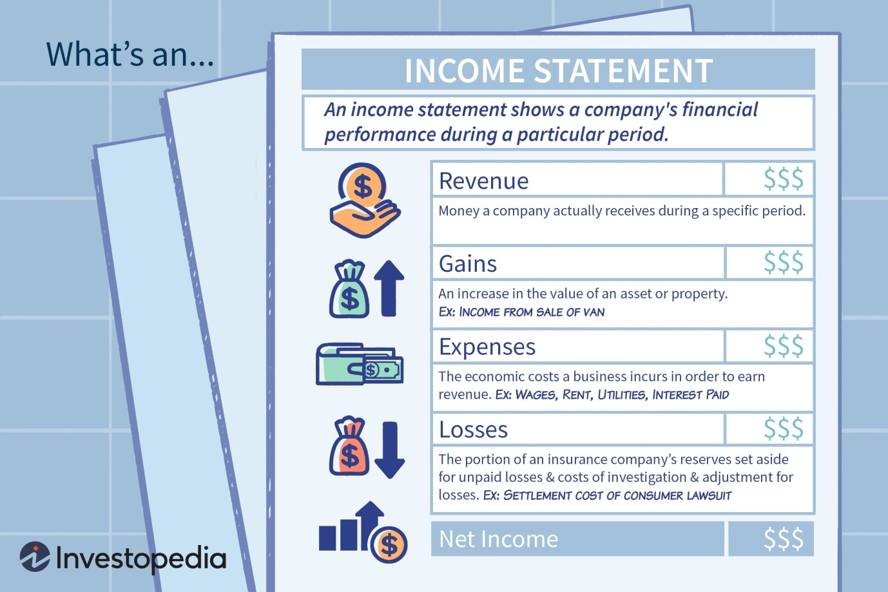

 Theresa Chiechi {Copyright} Investopedia, 2019.

The income statement focuses on the four key items - [revenue](https://www.investopedia.com/terms/r/revenue.asp), [expenses](https://www.investopedia.com/terms/e/expense.asp), gains, and losses. It does not cover [receipts](https://www.investopedia.com/terms/r/receipt.asp) (money received by the business) or the cash payments/disbursements (money paid by the business). It starts with the details of sales, and then works down to compute the [net income](https://www.investopedia.com/terms/n/netincome.asp) and eventually the [earnings per share (EPS)](https://www.investopedia.com/terms/e/eps.asp). Essentially, it gives an account of how the net revenue realized by the company gets transformed into net earnings (profit or loss).

### Key Takeaways

* An income statement is [one of the three (along with balance sheet and statement of cash flows) major financial statements](https://www.investopedia.com/ask/answers/031815/how-are-three-major-financial-statements-related-each-other.asp) that reports a company's financial performance over a specific accounting period.
* Net Income = (Total Revenue + Gains) – (Total Expenses + Losses)
* Total revenue is the sum of both operating and non-operating revenues while total expenses include those incurred by primary and secondary activities.
* Revenues are not receipts. Revenue is earned and reported on the income statement. Receipts (cash received or paid out) are not.
* An income statement provides valuable insights into a company’s operations, the efficiency of its management, under-performing sectors and its performance relative to industry peers.

## Revenues and Gains

The following are covered in the income statement, though its format may vary depending upon the local regulatory requirements, the diversified scope of the business and the associated operating activities:

### Operating Revenue

Revenue realized through primary activities is often referred to as [operating revenue](https://www.investopedia.com/terms/o/operating-revenue.asp). For a company manufacturing a product, or for a wholesaler, distributor or retailer involved in the business of selling that product, the revenue from primary activities refers to revenue achieved from the sale of the product. Similarly, for a company (or its franchisees) in the business of offering services, revenue from primary activities refers to the revenue or fees earned in exchange of offering those services.

### Non-Operating Revenue

Revenues realized through secondary, non-core business activities are often referred to as non-operating recurring revenues. These revenues are sourced from the earnings which are outside of the purchase and sale of goods and services and may include income from interest earned on business capital lying in the bank, rental income from business property, income from strategic partnerships like royalty payment receipts or income from an advertisement display placed on business property.

### Gains

Also called other income, gains indicate the net money made from other activities, like the sale of long-term assets. These include the net income realized from one-time non-business activities, like a company selling its old transportation van, unused land, or a subsidiary company.

Revenue should not be confused with receipts. Revenue is usually accounted for in the period when sales are made or services are delivered. Receipts are the cash received and are accounted for when the money is actually received. For instance, a customer may take goods/services from a company on 28 September, which will lead to the revenue being accounted for in the month of September. Owing to his good reputation, the customer may be given a 30-day payment window. It will give him time till 28 October to make the payment, which is when the receipts are accounted for.

## Expenses and Losses:

The cost for a business to continue operation and turn a profit is known as an expense. Some of these [expenses](https://www.investopedia.com/ask/answers/052815/how-are-prepaid-expenses-recorded-income-statement.asp) may be written off on a tax return if they meet the IRS guidelines.

### Primary Activity Expenses

All expenses incurred for earning the normal operating revenue linked to the primary activity of the business. They include the [cost of goods sold (COGS)](https://www.investopedia.com/terms/c/cogs.asp), selling, general and administrative expenses (SG&A), [depreciation](https://www.investopedia.com/terms/d/depreciation.asp) or [amortization](https://www.investopedia.com/terms/a/amortization.asp), and research and development (R&D) expenses. Typical items that make up the list are employee wages, sales commissions, and expenses for utilities like electricity and transportation.

### Secondary Activity Expenses

All expenses linked to non-core business activities, like interest paid on loan money.

### Losses as Expenses

All expenses that go towards a loss-making sale of long-term assets, one-time or any other unusual costs, or expenses towards lawsuits.

While primary revenue and expenses offer insights into how well the company’s core business is performing, the secondary revenue and expenses account for the company’s involvement and its expertise in managing the ad-hoc, non-core activities. Compared to the income from the sale of manufactured goods, a substantially high-interest income from money lying in the bank indicates that the business may not be utilizing the available cash to its full potential by expanding the production capacity, or it is facing challenges in increasing its market share amid competition. Recurring rental income gained by hosting billboards at the company factory situated along a highway indicates that the management is capitalizing upon the available resources and assets for additional profitability.

## Income Statement Structure

Mathematically, the Net Income is calculated based on the following:

**Net Income = (Revenue + Gains) – (Expenses + Losses)**

To understand the above details with some real numbers, let’s assume that a fictitious sports merchandise business, which additionally provides training, is reporting its income statement for the most recent quarter.

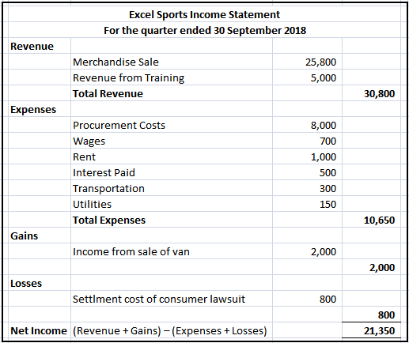

It received $25,800 from the sale of sports goods and $5,000 from training services. It spent various amounts as listed for the given activities that total $10,650. It realized net gains of $2,000 from the sale of an old van, and incurred losses worth $800 for settling a dispute raised by a consumer. The net income comes to $21,350 for the given quarter. The above example is the simplest forms of the income statement that any standard business can generate. It is called the **Single-Step Income Statement** as it is based on the simple calculation that sums up revenue and gains and subtracts expenses and losses.

However, real-world companies often operate on a global scale, have diversified business segments offering a mix of products and services, and frequently get involved in mergers, [acquisitions](https://www.investopedia.com/terms/a/acquisition.asp), and strategic partnerships. Such wide array of operations, diversified set of expenses, various business activities, and the need for reporting in a standard format as per regulatory compliance leads to multiple and complex accounting entries in the income statement.

Listed companies follow the **Multiple-Step Income Statement**which segregates the operating revenues, operating expenses, and gains from the non-operating revenues, non-operating expenses, and losses, and offer many more details through the income statement. Essentially, the different measures of profitability in a multiple-step income statement are reported at four different levels in a business' operations – gross, operating, pre-tax and after-tax. As we shall shortly see in the following example, this segregation helps in identifying how the income and profitability are moving/changing from one level to the other. For instance, high gross profit but lower operating income indicates higher expenses, while higher pre-tax profit and lower post-tax profit indicates loss of earnings to taxes and other one-time, unusual expenses.

Let’s look at the most recent annual income statements of two large, publicly-listed, multinational companies from different sectors of Technology (Microsoft) and Retail (Walmart).

(See also [Differences Between Single-Step vs. Multiple-Step Income Statements](https://www.investopedia.com/ask/answers/102714/what-are-main-differences-between-single-step-and-multiple-step-income-statements.asp)).

## Income Statement Example

Data Courtesy: Yahoo! Finance

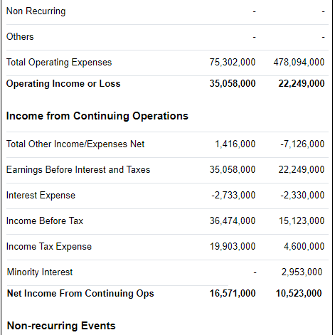

## Reading Standard Income Statements

The focus in this standard format is to calculate the profit/income at each subhead of revenue and operating expenses and then account for mandatory taxes, interest, and other non-recurring, one-time events to arrive at the net income that is applicable to common stock. Though calculations involve simple additions and subtractions, the order in which the various entries appear in the statement and their relations often gets repetitive and complicated. Let’s take a deep dive into these numbers for better understanding.

### Revenue Section

The first section titled “Revenue” indicates that Microsoft’s [Gross (annual) Profit](https://www.investopedia.com/terms/g/grossprofit.asp) for the fiscal year ending June 30, 2018, was $72.007 billion. It was arrived at by deducting the cost of revenue ($38.353 billion) from the total revenue ($110.360 billion) realized by the technology giant during its fiscal year. Around 35% of Microsoft’s total sales went toward costs for revenue generation, while a similar figure for Walmart was around 75% ($373.396/$500.343). It indicates that Walmart incurred much higher cost compared to Microsoft to generate equivalent sales.

### Operating Expenses

The next section called “Operating Expenses” again takes into account the cost of revenue ($38.353 billion) and total revenue ($110.360 billion) to arrive at the reported figures. As Microsoft spent $14.726 billion on research and development (R&D) and $22.223 billion on [Selling General and Administrative Expense](https://www.investopedia.com/terms/s/sga.asp) (SG&A) the Total Operating Expenses is computed by summing all these figures ($38.353 + $14.726 + $22.223) = $75.302 billion.

Reducing the total operating expenses from total revenue leads to Operating Income (or Loss) as ($110.360 - $75.302) = $35.058 billion. This figure represents the [Earnings Before Interest and Taxes](https://www.investopedia.com/terms/e/ebit.asp) (EBIT) for its core business activities and is again used later to derive the net income.

A comparison of the line items indicates that Walmart did not spend anything on R&D, and had higher SGA and total operating expenses compared to Microsoft.

### Income from Continuing Operations

The next section titled “Income from Continuing Operations” adds net other income or expenses (like one time earnings), interest-linked expenses and applicable taxes to arrive at the Net Income From Continuing Operations ($16.571 billion) for Microsoft, which is 60% higher than that of Walmart ($10.523 billion).

After discounting for any non-recurring events, the value of net income applicable to common shares is arrived at. Microsoft had a 68% higher net income of $16.571 billion compared to Walmart’s $9.862 billion.

The [earnings per share](https://www.investopedia.com/terms/e/eps.asp) are computed by dividing the net income figure by the number of weighted average shares outstanding. With 7.7 billion outstanding shares of Microsoft, its EPS comes to $16.571 billion/7.7 billion = $2.15 per share. With Walmart having 2.995 billion outstanding shares, its EPS comes to $3.29 per share.

Though the retail giant beats the technology leader in terms of annual EPS, Microsoft had a lower cost for generating equivalent revenue, higher net income from continuing operations, and higher net income applicable to common shares compared to Walmart.

## Uses of Income Statements

Though the main purpose of an income statement is to convey details of profitability and business activities of the company to the stakeholders, it also provides detailed insights into the company’s internals for comparison across different businesses and sectors. Such statements are also prepared more frequently at the department- and segment-levels to gain deeper insights by the company management for checking the progress of various operations throughout the year, though such interim reports may remain internal to the company.

Based on income statements, management can make decisions like expanding to new geographies, pushing sales, increasing production capacity, increased utilization or outright sale of assets, or shutting down a department or product line. Competitors may also use them to gain insights about the success parameters of a company and focus areas as increasing R&D spends.

Creditors may find limited use of income statements as they are more concerned about a company’s future cash flows, instead of its past profitability. Research analysts use the income statement to compare year-on-year and quarter-on-quarter performance. One can infer whether a company's efforts in reducing the cost of sales helped it improve profits over time, or whether the management managed to keep a tab on operating expenses without compromising on profitability.

# Sources of Finance (https://efinancemanagement.com/sources-of-finance)

Sources of finance for business are equity, debt, debentures, retained earnings, term loans, working capital loans, letter of credit, euro issue, venture funding etc. These sources of funds are used in different situations. They are classified based on time period, ownership and control, and their source of generation. It is ideal to evaluate each source of capital before opting for it.

Sources of capital are the most explorable area especially for the entrepreneurs who are about to start a new business. It is perhaps the toughest part of all the efforts. There are various capital sources, we can classify on the basis of different parameters.

Having known that there are many alternatives to finance or capital, a company can choose from. Choosing [the right source](https://efinancemanagement.com/sources-of-finance/how-to-choose-right-source-of-finance-for-your-business) and the [right mix of finance](https://efinancemanagement.com/financial-leverage/capital-structure-and-its-theories) is a key challenge for every finance manager. The process of selecting the right source of finance involves in-depth analysis of each and every source of fund. For analyzing and comparing the sources, it needs the understanding of all the characteristics of the financing sources. There are many characteristics on the basis of which sources of finance are classified.

On the basis of a time period, sources are classified as long-term, medium term, and short term. Ownership and control classify sources of finance into owned and borrowed capital. Internal sources and external sources are the two sources of generation of capital. All the sources have different characteristics to suit different types of requirements. Let’s understand them in a little depth.

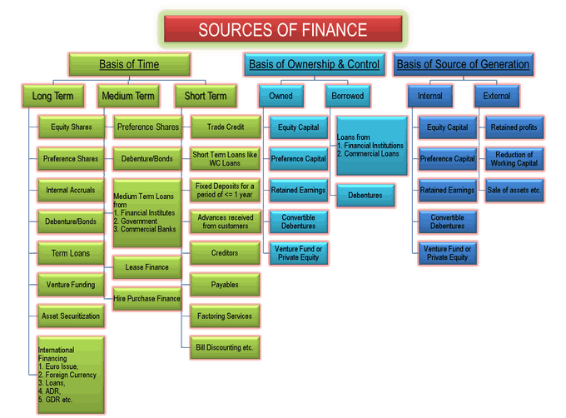

**According to Time Period**

Sources of financing a business are classified based on the time period for which the money is required. The time period is commonly classified into the following three:

|  |  |  |
| --- | --- | --- |
| **LONG TERM SOURCES OF FINANCE / FUNDS** | **MEDIUM TERM SOURCES OF FINANCE / FUNDS** | **SHORT TERM SOURCES OF FINANCE / FUNDS** |
| Share Capital or Equity Shares | Preference Capital or Preference Shares | Trade Credit |
| Preference Capital or Preference Shares | Debenture / Bonds | Factoring Services |
| Retained Earnings or Internal Accruals | Lease Finance | Bill Discounting etc. |
| Debenture / Bonds | Hire Purchase Finance | Advances received from customers |
| Term Loans from Financial Institutes, Government, and Commercial Banks | Medium Term Loans from Financial Institutes, Government, and Commercial Banks | Short Term Loans like Working Capital Loans from Commercial Banks |
| Venture Funding |  | Fixed Deposits (<1 Year) |
| Asset Securitization |  | Receivables and Payables |
| International Financing by way of Euro Issue, Foreign Currency Loans, ADR, GDR etc. |  |  |

## **Long-Term Sources of Finance**

[Long-term financing](https://efinancemanagement.com/sources-of-finance/long-term-finance) means capital requirements for a period of more than 5 years to 10, 15, 20 years or maybe more depending on other factors. Capital expenditures in fixed assets like plant and machinery, land and building, etc of business are funded using long-term sources of finance. Part of working capital which permanently stays with the business is also financed with long-term sources of funds. Long-term financing sources can be in the form of any of them:

* [Share Capital or Equity Shares](https://efinancemanagement.com/sources-of-finance/equity-share-and-its-types)
* [Preference Capital or Preference Shares](https://efinancemanagement.com/sources-of-finance/preference-shares-and-its-features)
* Retained Earnings or Internal Accruals
* [Debenture](https://efinancemanagement.com/sources-of-finance/benefits-and-disadvantages-of-debentures) / [Bonds](https://efinancemanagement.com/sources-of-finance/bonds-and-their-types)
* [Term Loans](https://efinancemanagement.com/sources-of-finance/term-loan-or-project-finance-a-long-term-source-of-finance) from Financial Institutes, Government, and Commercial Banks
* [Venture Funding](https://efinancemanagement.com/sources-of-finance/venture-funding)
* Asset Securitization
* International Financing by way of[Euro Issue](https://efinancemanagement.com/sources-of-finance/euro-issues), Foreign Currency Loans,[ADR](https://efinancemanagement.com/sources-of-finance/american-depository-receipt), [GDR](https://efinancemanagement.com/sources-of-finance/global-depository-receipt), etc.

## **Medium Term Sources of Finance**

Medium term financing means financing for a period of 3 to 5 years and is used generally for two reasons. One, when long-term capital is not available for the time being and second when deferred revenue expenditures like advertisements are made which are to be written off over a period of 3 to 5 years. Medium term financing sources can in the form of one of them:

* Preference Capital or Preference Shares
* Debenture / Bonds
* Medium Term Loans from
  + Financial Institutes
  + Government, and
  + Commercial Banks
* [Lease Finance](https://efinancemanagement.com/sources-of-finance/advantages-and-disadvantages-of-leasing)
* [Hire Purchase Finance](https://efinancemanagement.com/sources-of-finance/hire-purchase)

## **Short Term Sources of Finance**

Short term financing means financing for a period of less than 1 year. The need for short-term finance arises to finance the current assets of a business like an inventory of raw material and finished goods, debtors, minimum cash and bank balance etc. Short-term financing is also named as working capital financing. Short term finances are available in the form of:

* [Trade Credit](https://efinancemanagement.com/working-capital-financing/disadvantages-of-trade-credit)
* Short Term Loans like [Working Capital Loans](https://efinancemanagement.com/working-capital-financing/working-capital-loan-and-finance) from Commercial Banks
* Fixed Deposits for a period of 1 year or less
* Advances received from customers
* Creditors
* Payables
* [Factoring](https://efinancemanagement.com/sources-of-finance/factoring) Services
* [Bill Discounting](https://efinancemanagement.com/working-capital-financing/invoice-discounting-or-bill-discounting-or-purchasing-bills) etc.

**According to Ownership and Control:**

Sources of finances are classified based on ownership and control over the business. These two parameters are an important consideration while selecting a source of funds for the business. Whenever we bring in capital, there are two types of costs – one is the interest and another is sharing ownership and control. Some entrepreneurs may not like to dilute their ownership rights in the business and others may believe in sharing the risk.

|  |  |
| --- | --- |
| **OWNED CAPITAL** | **BORROWED CAPITAL** |
| Equity | Financial institutions, |
| Preference | Commercial banks or |
| Retained Earnings | The general public in case of debentures. |
| Convertible Debentures |  |
| Venture Fund or Private Equity |  |

## **Owned Capital**

Owned capital also refers to equity. It is sourced from promoters of the company or from the general public by issuing new equity shares. Promoters start the business by bringing in the required money for a startup. Following are the sources of Owned Capital:

* Equity
* Preference
* Retained Earnings
* Convertible Debentures
* Venture Fund or Private Equity

Further, when the business grows and internal accruals like profits of the company are not enough to satisfy financing requirements, the promoters have a choice of selecting ownership capital or non-ownership capital. This decision is up to the promoters. Still, to discuss, certain advantages of equity capital are as follows:

* It is a long-term capital which means it stays permanently with the business.
* There is no burden of paying interest or installments like borrowed capital. So, the risk of bankruptcy also reduces. Businesses in infancy stages prefer equity for this reason.

## **Borrowed Capital**

Borrowed or debt capital is the finance arranged from outside sources. These [sources of debt financing](https://efinancemanagement.com/sources-of-finance/sources-of-debt-financing) include the following:

* Financial institutions,
* Commercial banks or
* The general public in case of debentures

In this type of capital, the borrower has a charge on the assets of the business which means the company will pay the borrower by selling the assets in case of liquidation. Another feature of the borrowed fund is a regular payment of fixed interest and repayment of capital. Certain advantages of borrowing are as follows:

* There is no dilution in ownership and control of the business.
* The cost of borrowed funds is low since it is a deductible expense for taxation purpose which ends up saving on taxes for the company.
* It gives the business the benefit of leverage.

**ACCORDING TO SOURCE OF GENERATION:**

Based on the source of generation, the following are the **internal and external sources of finance:**

|  |  |
| --- | --- |
| **INTERNAL SOURCES** | **EXTERNAL SOURCES** |
| Retained profits | Equity |
| Reduction or controlling of working capital | Debt or Debt from Banks |
| Sale of assets etc. | All others except mentioned in Internal Sources |

## **Internal Sources**

The [internal source of capital](https://efinancemanagement.com/sources-of-finance/internal-source-of-finance) is the one which is generated internally by the business. These are as follows:

* Retained profits
* Reduction or controlling of working capital
* Sale of assets etc.

The internal source of funds has the same characteristics of owned capital. The best part of the internal sourcing of capital is that the business grows by itself and does not depend on outside parties. Disadvantages of both equity and debt are not present in this form of financing. Neither ownership dilutes nor fixed obligation/bankruptcy risk arises.

## **External Sources**

An [external source of finance](https://efinancemanagement.com/sources-of-finance/external-source-of-finance-capital) is the capital generated from outside the business. Apart from the internal sources of funds, all the sources are external sources.

Deciding the [right source of funds](https://efinancemanagement.com/sources-of-finance/how-to-choose-right-source-of-finance-for-your-business) is a crucial business decision taken by top-level finance managers. The usage of the wrong source increases the cost of funds which in turn would have a direct impact on the feasibility of the project under concern. Improper match of the type of capital with business requirements may go against the smooth functioning of the business. For instance, if fixed assets, which derive benefits after 2 years, are financed through short-term finances will create cash flow mismatch after one year and the manager will again have to look for finances and pay the fee for raising capital again.

# What is Mergers & Acquisitions?

Mergers and acquisitions (M&A) are defined as consolidation of companies. Differentiating the two terms, **Mergers** is the combination of two companies to form one, while **Acquisitions** is one company taken over by the other. M&A is one of the major aspects of corporate finance world. The reasoning behind M&A generally given is that two separate companies together create more value compared to being on an individual stand. With the objective of wealth maximization, companies keep evaluating different opportunities through the route of merger or acquisition.



## Mergers & Acquisitions can take place:

• by purchasing assets

• by purchasing common shares

• by exchange of shares for assets

• by exchanging shares for shares

## Types of Mergers and Acquisitions:

Merger or amalgamation may take two forms: merger through absorption or merger through consolidation. Mergers can also be classified into three types from an economic perspective depending on the business combinations, whether in the same industry or not, into horizontal ( two firms are in the same industry), vertical (at different production stages or value chain) and conglomerate (unrelated industries). From a legal perspective, there are different types of mergers like short form merger, statutory merger, subsidiary merger and merger of equals.

## Reasons for Mergers and Acquisitions:

• Financial synergy for lower cost of capital

• Improving company’s performance and accelerate growth

• Economies of scale

• Diversification for higher growth products or markets

• To increase market share and positioning giving broader market access

• Strategic realignment and technological change

• Tax considerations

• Under valued target

• Diversification of risk

## Principle behind any M&A is 2+2=5

There is always synergy value created by the joining or merger of two companies. The synergy value can be seen either through the Revenues (higher revenues), Expenses (lowering of expenses) or the cost of capital (lowering of overall cost of capital).

## Three important considerations should be taken into account:

• The company must be willing to take the risk and vigilantly make investments to benefit fully from the merger as the competitors and the industry take heed quickly

• To reduce and diversify risk, multiple bets must be made, in order to narrow down to the one that will prove fruitful

• The management of the acquiring firm must learn to be resilient, patient and be able to adopt to the change owing to ever-changing business dynamics in the industry

## Stages involved in any M&A:

**Phase 1: Pre-acquisition review:** this would include self assessment of the acquiring company with regards to the need for M&A, ascertain the valuation (undervalued is the key) and chalk out the growth plan through the target.

**Phase 2**: **Search and screen targets:** This would include searching for the possible apt takeover candidates. This process is mainly to scan for a good strategic fit for the acquiring company.

**Phase 3**: **Investigate and valuation of the target:** Once the appropriate company is shortlisted through primary screening, detailed analysis of the target company has to be done. This is also referred to as due diligence.

**Phase 4: Acquire the target through negotiations**: Once the target company is selected, the next step is to start negotiations to come to consensus for a negotiated merger or a bear hug. This brings both the companies to agree mutually to the deal for the long term working of the M&A.

**Phase 5:Post merger integration:** If all the above steps fall in place, there is a formal announcement of the agreement of merger by both the participating companies.

## Reasons for the failure of M&A – Analyzed during the stages of M&A:

**Poor strategic fit:** Wide difference in objectives and strategies of the company

**Poorly managed Integration: Integration is often poorly managed without planning and design. This leads to failure of implementation**

**Incomplete due diligence:** Inadequate due diligence can lead to failure of M&A as it is the crux of the entire strategy

**Overly optimistic:** Too optimistic projections about the target company leads to bad decisions and failure of the M&A

Example: Breakdown in merger discussions between IBM and Sun Microsystems happened due to disagreement over price and other terms. 

## Recent Mergers and Acquisitions

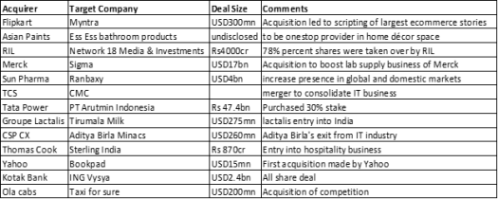

## Mergers and Acquisitions Case Study:

## Case Study 1: Sun Pharmaceuticals acquires Ranbaxy:

**The deal has been completed: The companies have got the approval of merger from different authorities.**

This is a classic example of a share swap deal. As per the deal, Ranbaxy shareholders will get four shares of Sun Pharma for every five shares held by them, leading to 16.4% dilution in the equity capital of Sun Pharma (total equity value is USD3.2bn and the deal size is USD4bn (valuing Ranbaxy at 2.2 times last 12 months sales).

**Reason for the acquisition:**This is a good acquisition for Sun Pharma as it will help the company to fill in its therapeutic gaps in the US, get better access to emerging markets and also strengthen its presence in the domestic market. Sun Pharma will also become the number one generic company in the dermatology space. (currently in the third position in US) through this merger.

**Objectives of the M&A:**

• Sun Pharma enters into newer markets by filling in the gaps in the offerings of the company, through the acquired company

• Boosting of products offering of Sun Pharma creating more visibility and market share in the industry

• Turnaround of a distressed business from the perspective of Ranbaxy

This acquisition although will take time to consolidate, it should in due course start showing results through overall growth depicted in Sun Pharma’s top-line and bottom-line reporting.

## Case Study 2: CMC merges with TCS:

This is an example where there is a merger in the same industry (horizontal). It was done to consolidate the IT businesses. The objective of this merger, as indicated by the management of CMC, was that the amalgamation will enable TCS to consolidate CMC’s operations into a single company with rationalised structure, enhanced reach, greater financial strength and flexibility. Further it also indicated that, it will aid in achieving economies of scale, more focused operational efforts, standardisation and simplification of business processes and productivity improvements.

Mergers and Acquisitions is an extremely important topic in CFA exam. The three levels of CFA exam build a foundation of Mergers and Acquisitions and will help you reach your dream job in this field.

About the CFA exam

**Eligibility:** Graduation + 2 years of professional work experience

**Duration:** 2 years 6 months (for all three level of exams)

**Top employers:**JP Morgan Chase, UBS, Citigroup, Bank of America

**Avg. salary range:**6.5 lacs to 18 lacs (Source: PayScale)  
[More Details about CFA program >>](https://www.edupristine.com/courses/cfa/cfa-level-i)

## Conclusion:

M&A’s are considered as important change agents and are a critical component of any business strategy. The known fact is that with businesses evolving, only the most innovative and nimble can survive. That is why, it is an important strategic call for a business to opt for any arrangements of M&A. Once through the process, on a lighter note M&A is like an arranged marriage, partners will take time to understand, mingle, but will end up giving positive results most of the times.

(<https://www.edupristine.com/blog/mergers-acquisitions>)

UNIT 4 :

# Product Life Cycle Development

**Definition**: The product life-cycle (PLC) refers to the different stages a product goes through from introduction to withdrawal.

The product life-cycle refers to a likely pathway a product may take. It has implications for the marketing strategy of a firm as it seeks to introduce, grow and maintain market share.

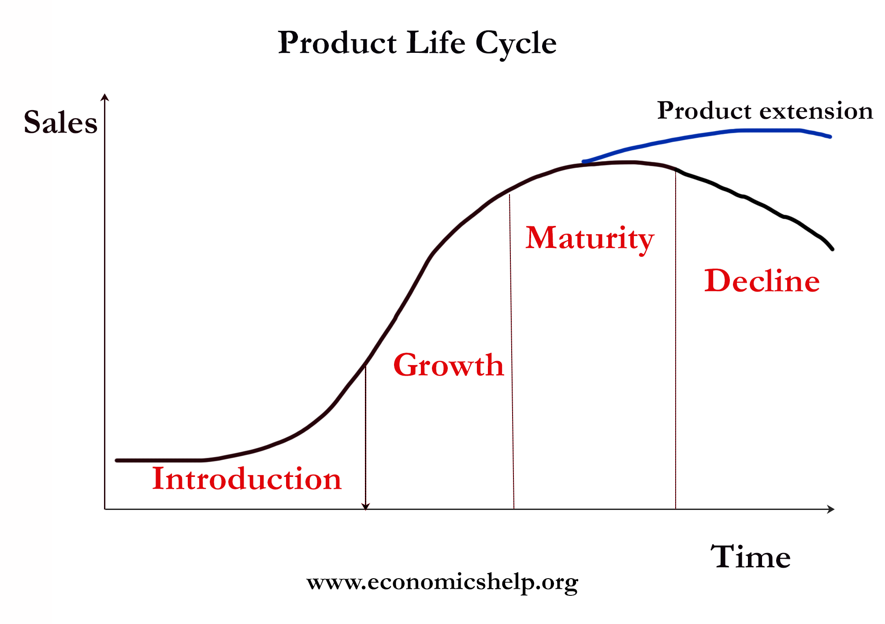

In this case, the product has four stages:

1. **Introduction** – when the product is introduced and struggles to gain brand recognition.
2. **Growth** – advertising and word of mouth helps the product to increase sales. As sales growth, more firms are willing to stock the product which helps the product to grow even further.
3. **Maturity** – When the product reaches peak market penetration.
4. **Decline** – the product gets eclipsed by new products

### Example of the Product Life Cycle 2018

1. **Introduction** – **Self-driving cars**. Self-driving cars are still at the testing stage, but firms hope to be able to sell to early adopters relatively soon.
2. **Growth** – Electric cars. For example, the **Tesla Model S** is in its growth phase. Electric cars still need to convince people that it will work and be practical. As there are more electric charging points and more people adopt, it becomes easier to sell to those who are more sceptical of new technology like electric cars.
3. **Maturity –** **Ford Focus**. The Ford Focus is a well-established car. It has a good brand reputation and has reached its peak level of market penetration. It would be difficult to gain a significantly greater market share. The product life cycle of the Ford Focus has been extended by constant upgrades and redesigns to keep the car on top of the market.
4. **Decline** – Diesel cars. Since governments have expressed concern at the level of pollution from diesel cars. Some cities have threatened to ban diesel cars within a few years. Sales have fallen considerably and the market for diesel cars may be in terminal decline.

### The usefulness of Product Life Cycle

In the different phases of the product life cycle firms, will need to concentrate on different aspects of marketing and sales

#### Introduction phase

* Raising product awareness through advertising / word of mouth.
* Offering the product at discount – penetration pricing to tempt customers to try the product.
* Target early adopters and influential market leaders. For example, firms may offer free product reviews to influential bloggers in the market.
* Firms need to find willing suppliers who are willing to stock.
* This phase will not be profitable because costs are high, but revenue relatively low.

#### Growth

* Firms need to capitalise on growth to extend product sales from small retailers to big supermarkets.
* Firms can change marketing from niche areas to a more mass market.
* The firm can adapt to consumer feedback and offer new features/better consumer support.

#### Maturity

* With peak market penetration, the firm may seek to increase prices to increase profitability. However, if the market is very competitive the firm may feel the need to keep prices low to defend market share.
* The firm may concentrate on seeking to improve the product to gain market differentiation and extend the period of maturity.

#### Decline

* In the decline phase, the firm may feel it is best to let the product go – e.g. diesel cars cannot solve issues of pollution and damage to its brand reputation. However, with an iPhone, Apple let old models go, to be replaced by the next model. Decline and discontinuing the product can be a way to force customers to buy an upgrade – next time their contract expires.
* Managed decline by targeting on a niche market. For example, vinyl records have declined, but now they have become a very profitable niche for record labels. Total sale revenues from vinyl are close to sale revenues from digital downloads because record companies can charge a premium price for the good.

### Different examples of product life cycles

**Stable products** – Some products have defied time to maintain the period of maturity for a considerable time. For example, products like Marmite, Kelloggs Corn Flakes and Evian mineral water seem fairly stable and immune to technological innovation.

**Maturity from the start**. Some products are launched to great fanfare and product awareness. For example, the iPhone X is related to previous iPhones so there is no need for an introduction phase. Other products like the Xbox are eagerly awaited. Rather than using penetration pricing, this products can practise price-skimming – where the firm takes advantage of inelastic demand.

**Failed products**. Many products never really escape the introduction phase. For example, failed product launches such as the mini-disc, Betamax.

**Reinvented products**. Some products have successfully reinvented themselves and proved to be more successful after a period of decline. For example, in the mid 1990s, Apple computers appeared to be in its decline phase, but in the late 90s and early 2000s, it successfully re-pioneered itself. You could say that the Apple MacBook is a different product to previous Apple computers. It depends on how you define a product. Vinyl records are enjoying a revival.

(<https://www.economicshelp.org/blog/140934/business/product-life-cycle/>)

# The four Ps of marketing: product, price, place and promotion

The **marketing mix** is the set of controllable, tactical marketing tools that a company uses to produce a desired response from its . It consists of everything that a company can do to influence demand for its product. It is also a tool to help marketing planning and execution.

The marketing mix can be divided into four groups of variables commonly known as the four Ps:

1. **Product:** The goods and/or services offered by a company to its customers.
2. **Price:** The amount of money paid by customers to purchase the product.
3. **Place (or distribution):** The activities that make the product available to consumers.
4. **Promotion:** The activities that communicate the product’s features and benefits and persuade customers to purchase the product.

## Marketing tools

Each of the four Ps has its own tools to contribute to the marketing mix:

* **Product:** variety, quality, design, features, brand name, packaging, services
* **Price:** list price, discounts, allowance, payment period, credit terms
* **Place:** channels, coverage, assortments, locations, inventory, transportation, logistics
* **Promotion:** advertising, personal selling, sales promotion, public relations

## Marketing strategy

An effective marketing strategy combines the 4 Ps of the marketing mix. It is designed to meet the company’s marketing objectives by providing its customers with value. The 4 Ps of the marketing mix are related, and combine to establish the product’s position within its target markets.

## Weaknesses of the marketing mix

The four Ps of the marketing mix have a number of weaknesses in that they omit or underemphasize some important marketing activities. For example, services are not explicitly mentioned, although they can be categorized as products (that is, service products). As well, other important marketing activities (such as packaging) are not specifically addressed but are placed within one of the four P groups.

Another key problem is that the four Ps focus on the seller’s view of the market. The buyer’s view should be marketing’s main concern.

## The four Ps as the four Cs

The four Ps of the marketing mix can be reinterpreted as the four Cs. They put the customer’s interests (the buyer) ahead of the marketer’s interests (the seller).

* Customer solutions, **not products:** Customers want to buy value or a solution to their problems.
* Customer cost, **not price:** Customers want to know the total cost of acquiring, using and disposing of a product.
* Convenience, **not place:** Customers want products and services to be as convenient to purchase as possible.
* Communication, **not promotion:** Customers want two-way communication with the companies that make the product.

( https://learn.marsdd.com/article/the-marketing-mix-in-marketing-strategy-product-price-place-and-promotion/)

# The Five Marketing Concepts Explained

16.11.2019



Despite the fact that modern business is changing rapidly and it’s radically different from 10, 20, or 50 years ago, some core marketing concepts have remained the same.   
  
**Marketing** is defined by the [American Marketing Association](safari-reader://en.wikipedia.org/wiki/American_Marketing_Association) as:  
  
 “the activity, set of institutions, and processes for creating, communicating, delivering, and exchanging offerings that have value for customers, clients, partners, and society at large.“   
  
**Marketing concepts** relate to the philosophy a business use to identify and fulfill the needs of its customers, benefiting both the customer and the company. Same philosophy cannot result in a gain to every business, hence different businesses use different marketing concepts (also called marketing management philosophies).   
  
The ‘marketing concept’ proposes that in order to satisfy the organizational objectives, an organization should anticipate the needs and wants of consumers and satisfy these more effectively than competitors. This concept originated from Adam Smith’s book [The Wealth of Nations](safari-reader://en.wikipedia.org/wiki/The_Wealth_of_Nations), but would not become widely used until nearly 200 years later.   
  
**Marketing and marketing concepts are directly related.**   
  
Given the importance of customer needs and wants in marketing, we have to understand them correctly.   
  
They have been [defined](http://journals.sagepub.com/doi/abs/10.1177/000765036800900106) long time ago as this:

* **Needs:** Something necessary for people to live a healthy, stable and safe life. When needs remain unfulfilled, there is a clear adverse outcome: a dysfunction or death. Needs can be objective and physical, such as the need for food, water and shelter; or subjective and psychological, such as the need to belong to a family or social group and the need for self-esteem.
* **Wants:** Something that is desired, wished for or aspired to. Wants are not essential for basic survival and are often shaped by culture.
* **Demands:** When needs and wants are backed by the ability to pay, they have the potential to become economic demands.

There are numerous marketing concepts which are used by marketers as a reference in the marketing field. Some of these marketing concepts exist to date, while some others are outdated and have been taken over by other marketing concepts.

## **The five marketing concepts**

The five marketing concepts are:

1. **Production concept**
2. **Product**
3. **Selling concept**
4. **Marketing concept**
5. **Societal marketing concept**

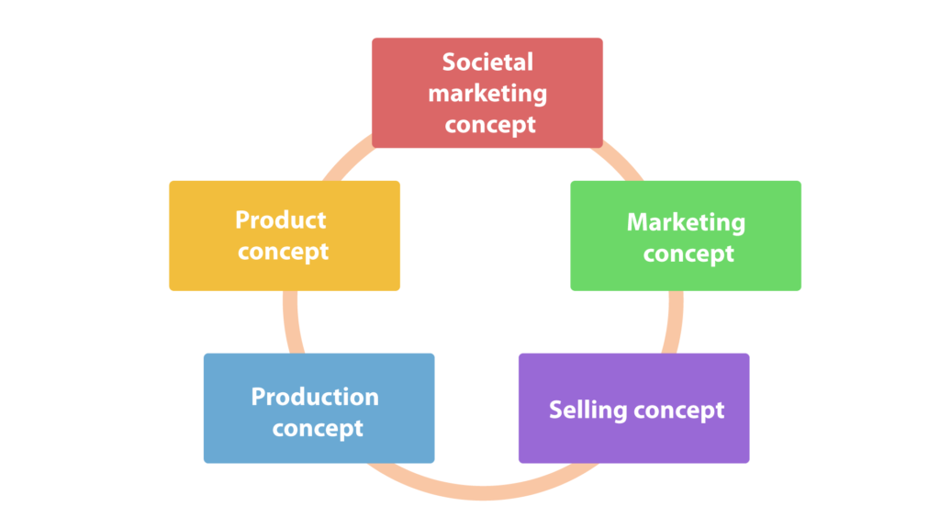

[Image source](safari-reader://cdn.marketing91.com/wp-content/uploads/2010/01/Concepts-of-Marketing.jpg)

Let’s take a closer look at each one.

## **The production concept**

When the production concept was defined, a production oriented business dominated the market. This was from the beginning of capitalism to the mid 1950’s.  
  
During the era of the production concept, businesses were concerned primarily with **production, manufacturing, and efficiency issues**.Companies that use the production concept have the belief that customers primarily want products that are affordable and accessible.   
  
The production concept is based on the approach that a company can increase supply as it decreases its costs.Moreover, the production concept highlights that a business can lower costs **via mass production.**A company oriented towards production **believes in economies of scale**(decreased production cost per unit), wherein mass production can decrease cost and maximize profits. As a whole, the production concept is oriented towards operations.

## **The product concept**

This concept works on an assumption that **customers prefer products of greater quality** **and price and availability** doesn’t influence their purchase decision. And so company develops a product of greater quality which usually turns out to be expensive.   
  
One of the best modern examples would be IT companies, who are always improving and updating their products, to differentiate themselves from the competition.Since the main focus of the marketers is the product quality, they often lose or fail to appeal to customers whose demands are driven by other factors like price, availability, usability, etc.

## **The selling concept**

Production and product concept both focus on production but selling concept focuses on making an actual sale of the product.Selling concept focuses on making every possible sale of the product, regardless of the quality of the product or the need of the customer.   
  
The selling concept highlights that customers would buy a company’s products **only if the company were to sell these products aggressively**.**This philosophy doesn’t include building relations with the customers**. This means that repeated sales are rare, and customer satisfaction is not great.

## **The marketing concept**

A company that believes in the marketing concept **places the consumer at the center of the organization**. All activities are geared towards the consumer.A business,aims to understand the needs and wants of a customer. It executes the marketing strategy according to market research beginning from product conception to sales.   
  
By focusing on the **needs and wants** of a target market, a company can deliver more value than its competitors. The marketing concept emphasizes the [“pull” strategy”](safari-reader://oxidian.ch/inbound-marketing/). This means that  a brand is so strong that customers would always prefer your brand to others’.

## **The societal marketing concept**

This is a relatively new marketing concept. While the societal marketing concept highlights the needs and wants of a target market and the delivery of better value than its competitors, it also **emphasizes the importance of the well-being of customers and society as a whole** (consumer welfare or societal welfare).   
  
The societal marketing concept calls upon marketers to build social and ethical considerations into their marketing practices. They must balance and juggle the often conflicting criteria of company profits, consumer want satisfaction, and public interest.

## **Conclusion**

The five marketing concepts are a good example of how marketing has changed throughout the years. It has shifted its focus from products to users.

(https://oxidian.ch/en/the-five-marketing-concepts-explained/)